Vaccines & DNA: Mythbusters Social Media Toolkit
Social Media Message: Getting a COVID-19 #vaccine CANNOT change your DNA. The vaccine teaches your body how to respond to the #COVID19 #virus, but it does not enter or change your genes. Learn more about how vaccines work at www.cdc.gov/coronavirus
#VacciNation #NativesStopTheSpread #StopTheSpread #Vaccinated #COVIDWarrior #SkoVaxDen
Instagram:
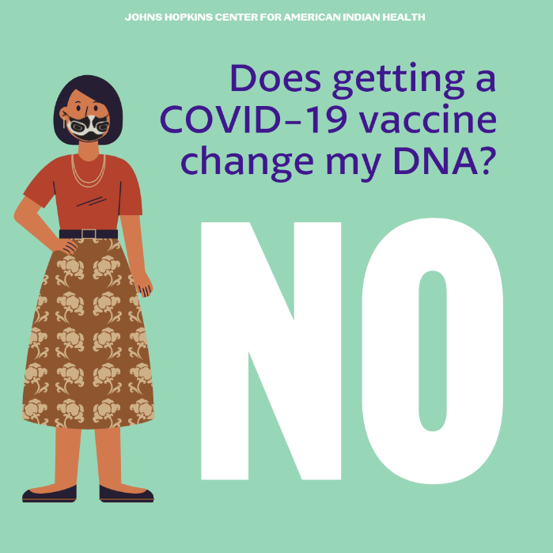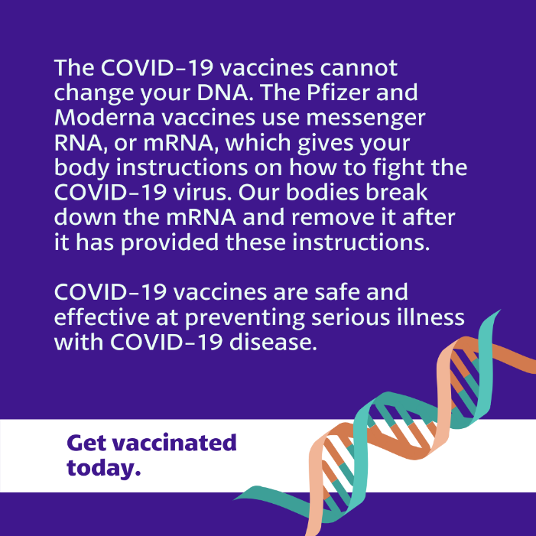

FB/Twitter: 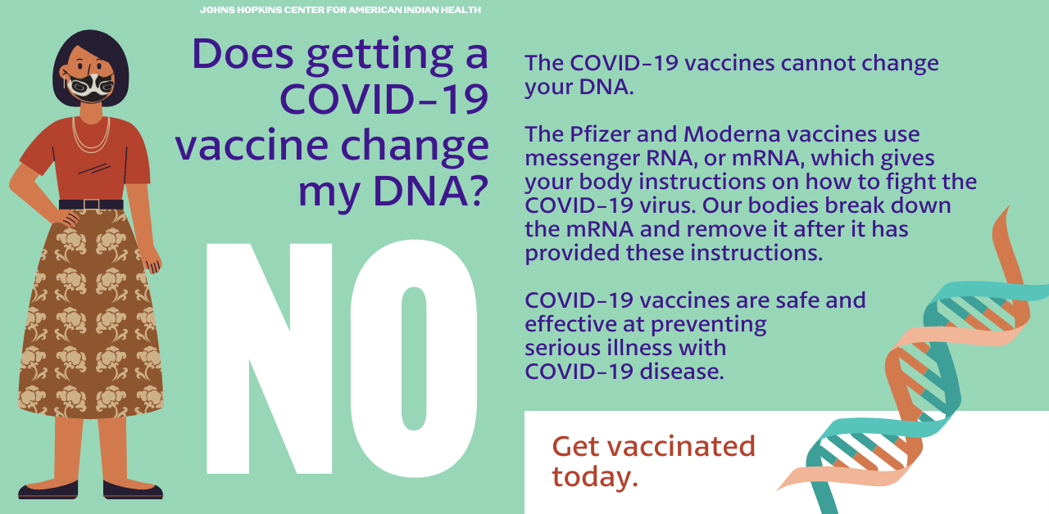
Tag:
@Anthctoday @Aaipdocs @CDCgov @HealthyNativeYouth @HonoringNations @IndianCountryToday @_IllumiNatives @IndianHealthBoard_Minneapolis @IndianHealthService
@Indianz @JohnsHopkinsSPH @NationalIndianHealthBoard @Npaihb @Nihb1 @NationalNativeNews @NativeAmericans @NativeAmericanLifelines @Nimhgov @NNNnativenews @ProjectMosaicllc @SeattleIndianHealthBoard @UrbanIndigenousCollective @UrbanIndianHealth
@UrbanIndianHealthInstitute @WeAreHealers @WeRNative @HealthyN8Vyouth @HonoringNations @_Illuminatives @JohnsHopkinssph @Npaihb @ProjectMosaicLLC @UrbanIndigenousCollective @Nimhgov @Nimhd @Nihb1 @UrbanIndianHealth @WeAreHealers

