Johnson & Johnson Safety: Social Media Toolkit
Social media message: We are addressing your questions about the Johnson & Johnson #vaccine after the temporary pause. The risk of developing blood clots after getting your J&J shot was found to be very rare – in fact, you are almost twice as likely to be struck by lightning than develop this side effect. Make sure to look for reliable sources for information – and get vaccinated when you can to protect you and your community from #COVID19.
Photo credit to Nina Mayer Ritchie @ninamayerritchie
1. 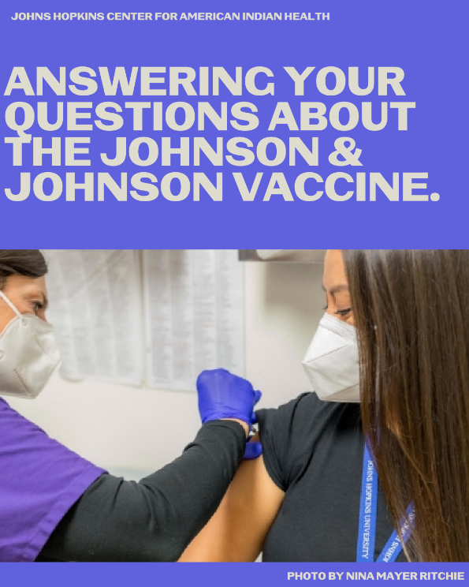 2. 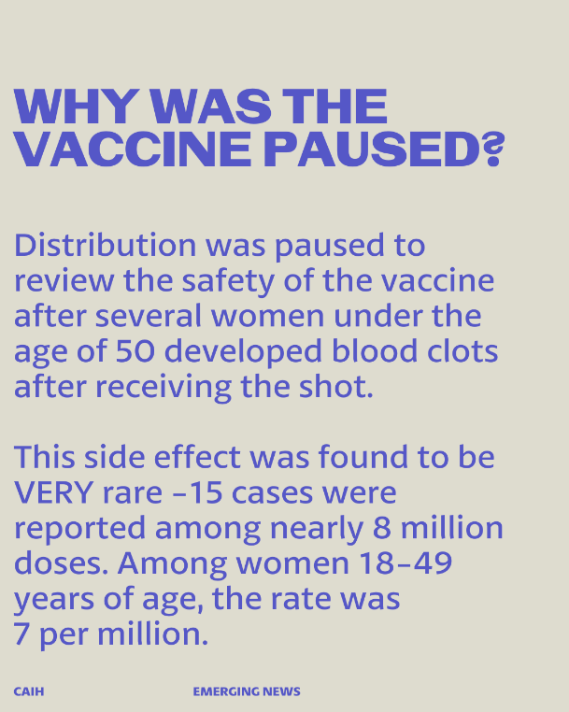
3. 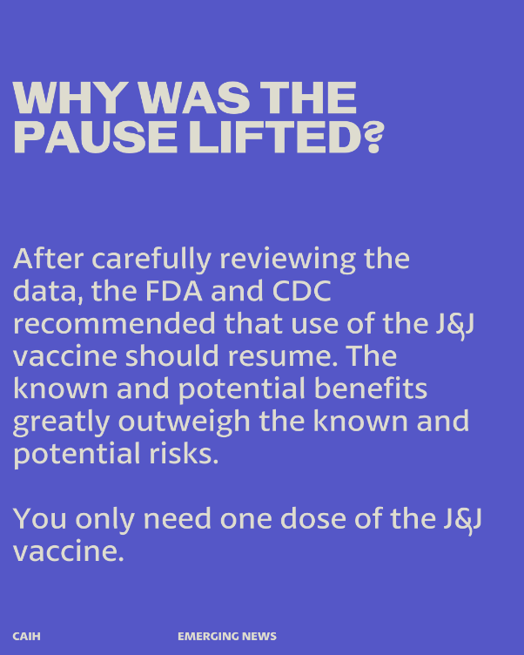 4. 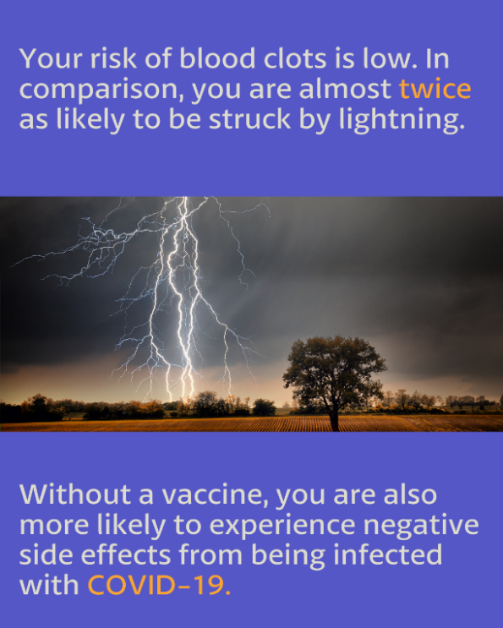
5. 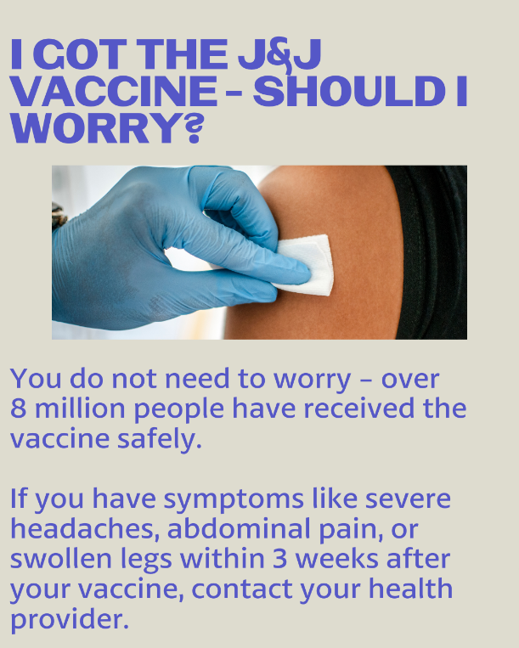 6. 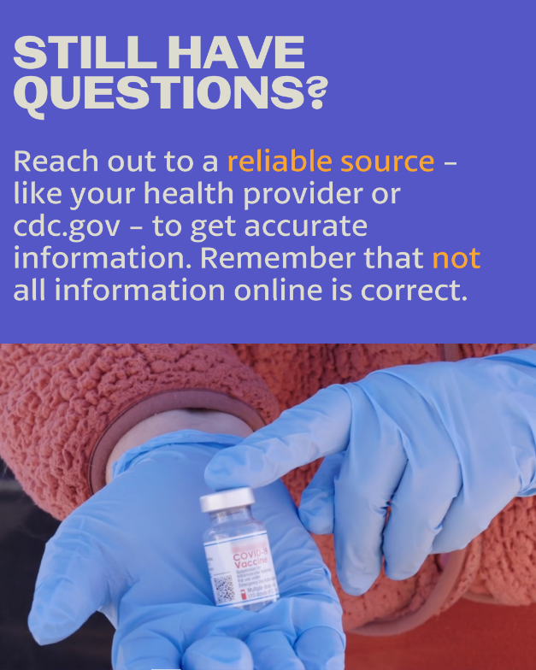
7. 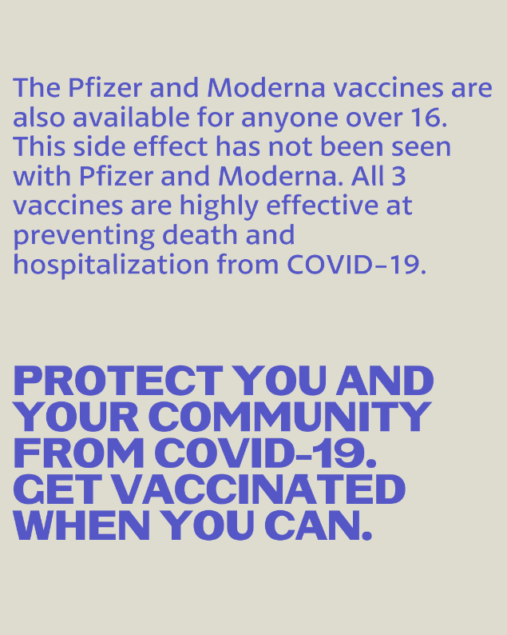 8. 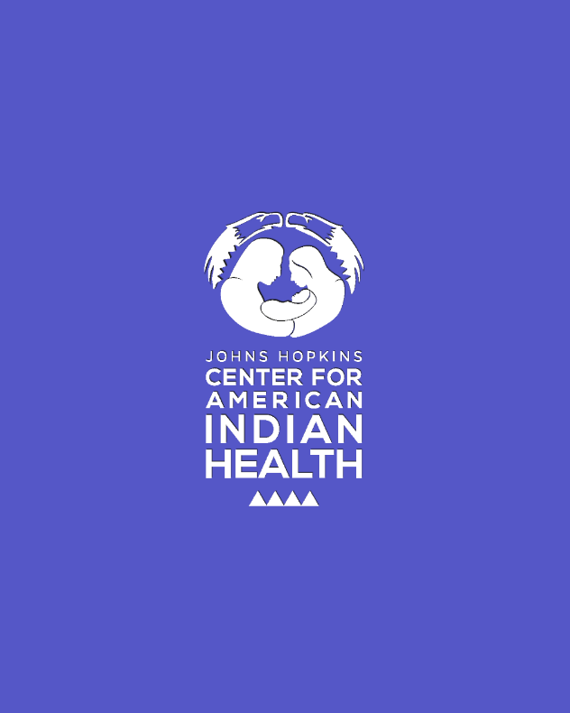

FACEBOOK/TWITTER
1. 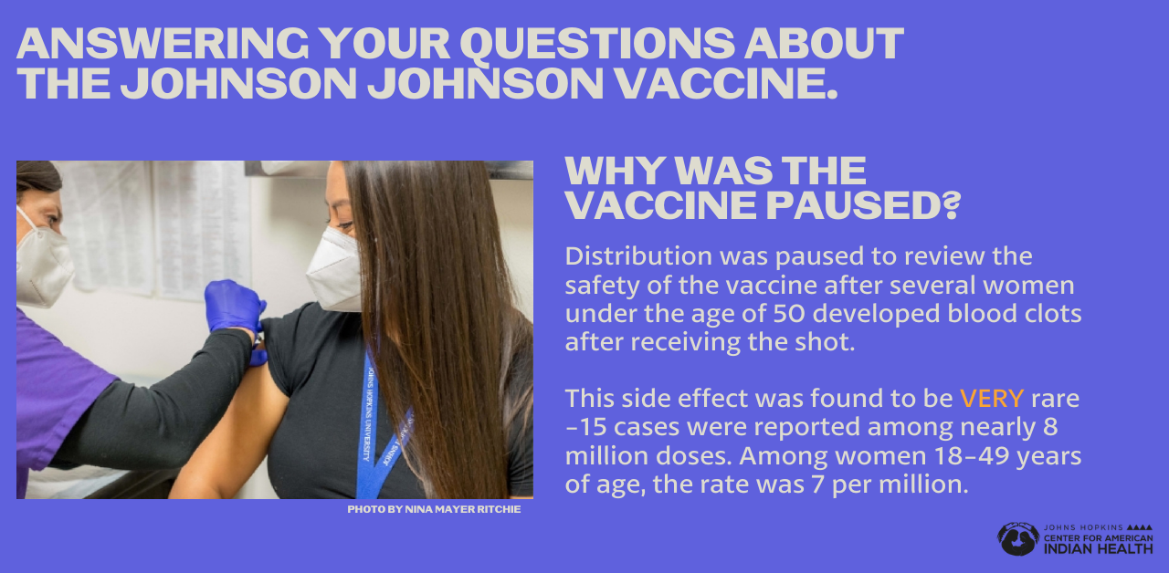
2. 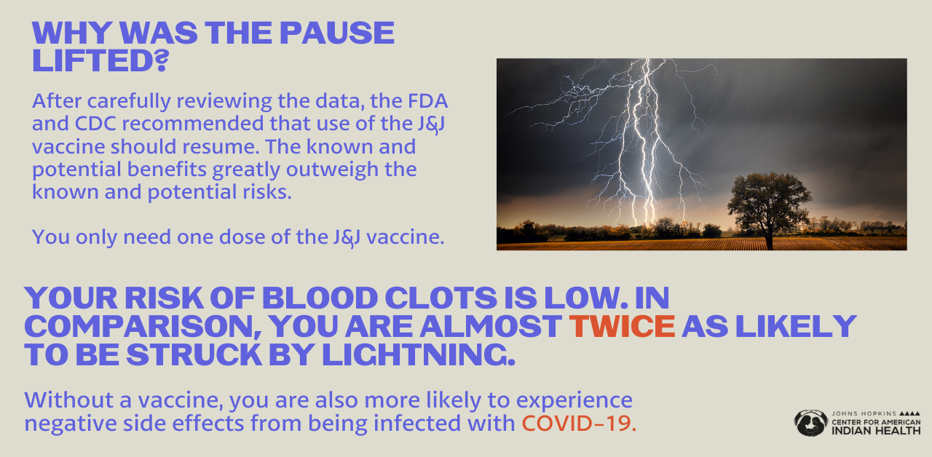
3. 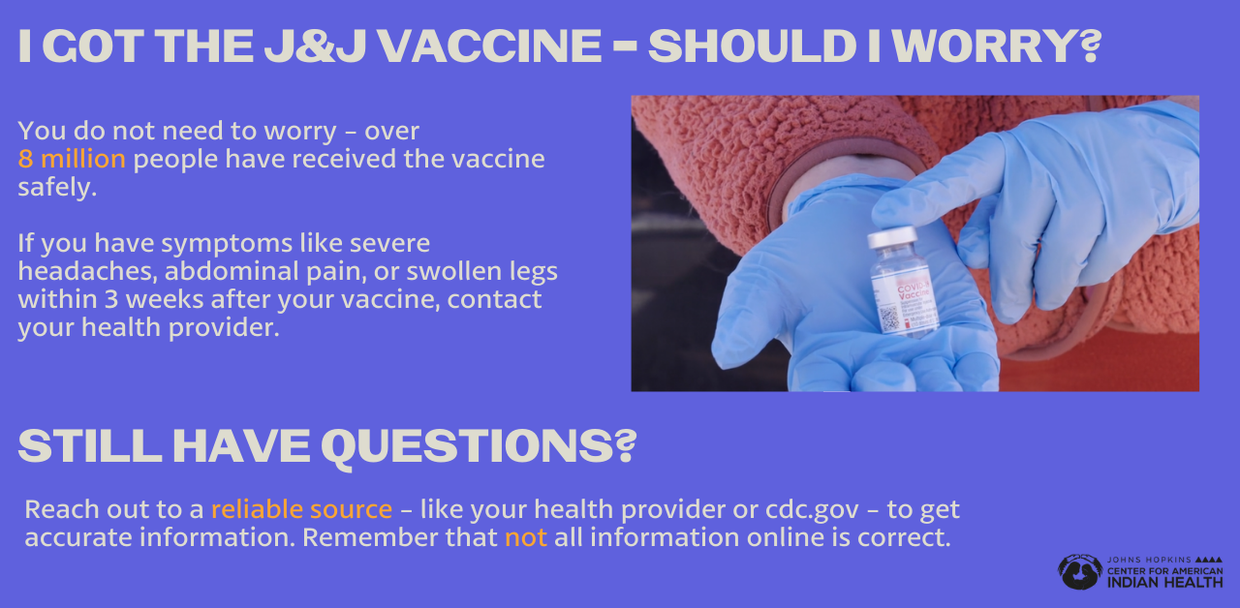

4. 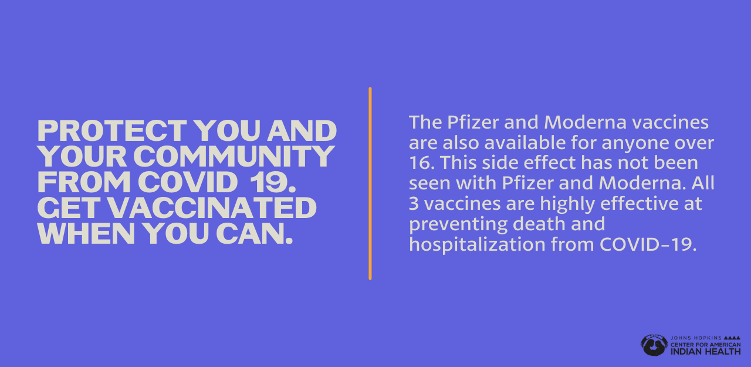

Partners to tag:
@anthctoday @CDCgov @HealthyN8VYouth @honoringnations @_illumiNatieOrg @IndianHealthService @johnshopkinssph @NativeAmericanLifelines @NCUIH @NIHB1972 @NIMHD @NNNnativenews @npaihb @projectmosaic @urbanindigenouscollective @weRnative @AssociationofAmericanIndianPhysicians @HealthyNativeYouth @Indiancountrytoday @IndianHealthService @IllumiNative @Indianz.com @HealthMilleLacsBandofOjibwe @NIMHD @MinnesotaAcademyofFamilyPhysicians @NavajoDepartmentofHealth @NewMexicoPublicHealthAssociation @NationalIndianHealthBoard @NorthwestPortlandAreaIndianHealthBoard @NationalIndianHealthBoard @NationalNativeNews @SeattleIndianHealthBoard @UrbanIndianHealthInstitute @UniversityofMinnesotaMedicalSchoolDuluthCampus

